Logging using SLF4J

Exercise 1 : Logging Error Messages and Warning Levels
Pom.xml

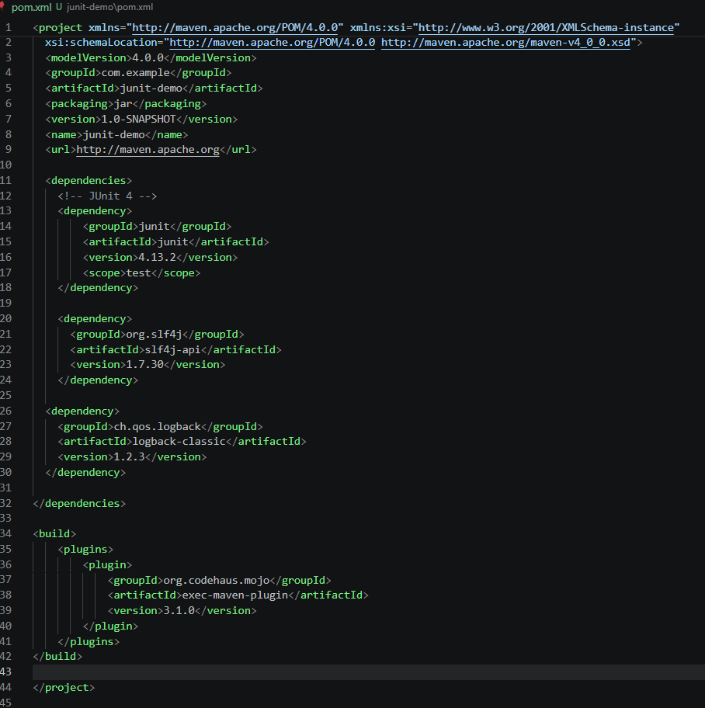

Created a Java class that uses SLF4J for logging:
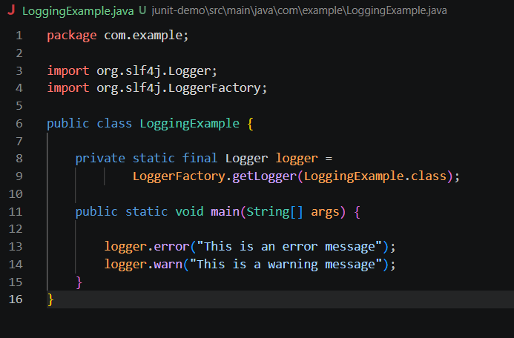

Screenshot of terminal output :
